Earth as an Apple
Grade Levels  9-12  Estimated time  One 40-minute sessions  Materials needed  computer, projector, internet, apples, plastic knives, cutting boards or plates, paper towels, student worksheets (in Appendix A), pencils | Purpose  This interactive lesson guides students to use an apple visualize and learn how portions of Earth’s surface are used and emphasizes the importance of our limited natural resource, soil. Students will be able to explain a pie chart representing Earth’s surface and how that area is used.  Introduction  When prompted, many people can list a few natural resources that humans could not survive without such as air, water, oil, etc. One invaluable resource is often overlooked or forgotten: soil. Soil supports our food system, contains microbial life, stores nutrients, purifies water, and more. But how much of the earth’s surface is soil that provides us food? This lesson walks students through a modeling and critical thinking exercise to answer that question.  Suggested Sequence  - Hook  - Watch the first 3 minutes and 19 seconds of “Why soil is one of the most amazing things on Earth” video by BBC Ideas.  - Ask the class to share something they learned about soil with a person next to them. Have 2-3 students share with the class.  - Tell the class, “Something that stood out to me was the value of soil. In the video, the narrator says that “it takes more than 100 years to build just 5 millimeters of soil.” We are going to continue thinking about and discussing how soil is a very important resource on Earth’s surface.”  - Tell the class, “We are going to use an apple to help us visualize how Earth’s surface is used and how much soil the world has.”  - This activity can be done in small groups, in pairs, or individually. Distribute or have each group collect the following supplies: 1 apple, 1 plastic knife, 1 cutting board or plate, and a few paper towels.  - Once the supplies are gathered and students are ready, demonstrate and reach the following prompts for each step.  - Step 1: Cut the apple into four equal wedges so you have four 1/4th sections.  - Step 2: Group three quarter sections of the apple together. This represents Earth’s oceans, which is 75% of Earth’s surface. Set these pieces aside.  - Step 3: Pick up the remaining quarter. This represents land, which is 25% of Earth’s surface.  - Step 4: Take the quarter (that represents land) and cut it into three equal wedges so you have three 1/12th sections.  - Step 5: Take one of the 1/12th sections. This piece represents land that is inhospitable including deserts, mountains, and polar regions. This land is not suitable for people to live or grow crops.  - Step 6: Group the remaining two 1/12th sections. Together, these slices represent habitable land. This is land where people can live and food can be grown.  - Step 7: Take one of these 1/12th wedges (that represents habitable land). This slice represents habitable land that is used for non-agricultural purposes. Nature preserves, public lands, and developed areas including roads, buildings, etc. cover this land.  - Step 8: Take the second 1/12th wedge (that represents habitable land). This section represents Earth's habitable land that is used for agricultural purposes.  - Step 9: Cut this section (that represents agricultural land) into four equal pieces so you have four 1/48th sections.  - Step 10: Group three 1/48th sections. This land is used to grow crops to feed livestock or grazing. Set these pieces aside.  - Step 11: Pick up the remaining 1/48th section. This represents the land used to grow crops for humans to eat.  - Step 12: Carefully remove the peel of the apple off of the slice 1/48th wedge. Compare the size of this small piece of apple peel to the other pieces and of the whole apple.  - Distribute activity worksheets (found in Appendix A). Instruct the students to complete worksheet with a partner or small group. Walk around the room to monitor student work, answer questions, and listen to small group discussion.  - At the end of class, wrap up the lesson by summarizing the lesson. The answer key for the activity worksheet can be used as a guide.

Extend the Lesson
This lesson can be extended by adding instruction or a reading activity regarding the importance of soil, best management practices to support soil health, and STAR (Saving Tomorrow’s Agricultural Resources). See Issues 6 and 7 2023 of the AIM newsletter for student reading material and for more information regarding this topic.
For more additional activities to follow up this lesson and continue the discussion of the importance of soil, see National Agriculture in the Classroom’s Earth’s Land and Soil Resources Lesson Plan.

Acknowledgements
This lesson is based on the lesson by National Agriculture in the Classroom and How Much Soil is There? lesson by Soil Science Society of America. Video referenced is provided by BBC Ideas.

Author
Kathryn Thuestad, Education and Outreach Coordinator with AIM

Appendix A

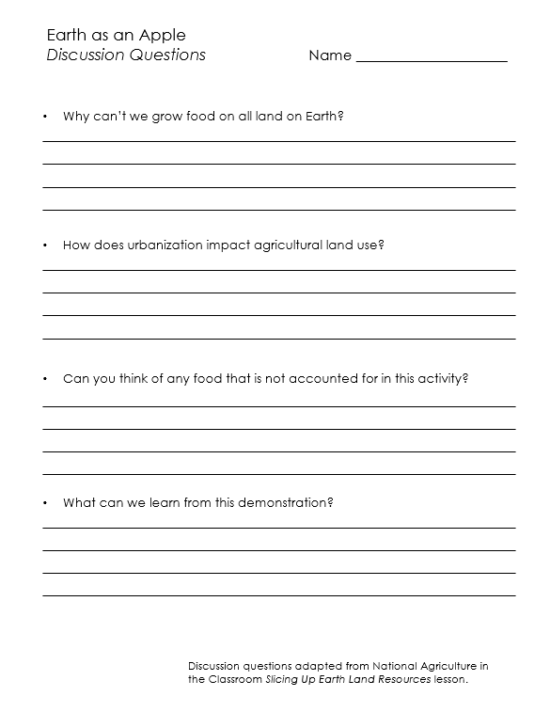
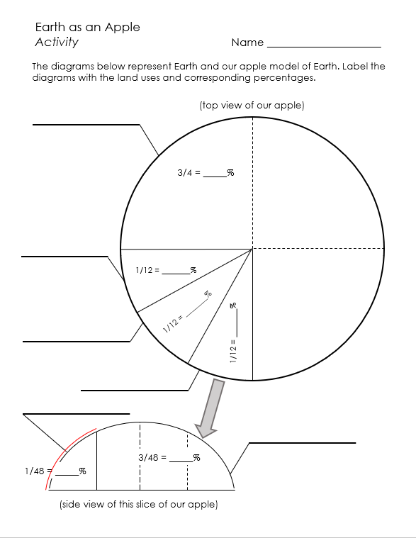
Activity Worksheet

Example PDF file and PPT file [replace link once added to online platform]

